Year 12
Student Handbook

Cheltenham Girls’ High School

2018 HSC
Contents
WHO CAN HELP YOU? 3
GENERAL INFORMATION ATTENDANCE 4
LATE ARRIVALS and EARLY LEAVE 4
YEAR 12 STUDY PERIOD PRIVILEGE 5
EARLY DEPARTURES 5
LEAVING DURING THE DAY AND PLANNING TO RETURN 5
WEEKLY YEAR MEETINGS 5
ABSENCE FROM CLASS 6
Application for any assessment tasks missed during the period of leave 6
STUDY PERIODS 6
SENIOR STUDY FACILITY 7
YEAR 12 SENIOR STUDY ROOM CODE OF CONDUCT 7
YEAR 12 JERSEYS 8
TIMELINE FOR YEAR 12 JERSEYS 9
SPORT 10
STUDENT CARS / STUDENT DRIVERS 10
STUDENTS ONLINE………………………………………………………………………………………………………………………………………….11
HSC REQUIREMENTS - HSC RULES AND REGULATIONS 12
STUDENT PATTERN OF STUDY 14
DETERMINING A STUDENT'S ACHIEVEMENT IN THE HSC 15
CHANGES TO YOUR PATTERN OF STUDY 20
HSC EXAMINATIONS: PROJECTS, SUBMITTED WORKS AND PERFORMANCES INFORMATION FOR STUDENTS 21
MALPRATICE 23
DISABILITY EXAMINATION PROVISIONS 25
RESEARCH LEAVE 27
COMPUTER WORK AND ASSESSMENT TASKS 27
REQUEST FOR A SCHOOL CHARACTER REFERENCE 28
FINAL WEEKS OF SCHOOL FOR YEAR 12 STUDENTS 29
PRESENTATION DAY 29

WHO CAN HELP YOU?

Principal: Mrs. S. Bridge
Deputy Principal: Ms S Hope
Year 12 Year Adviser: Mrs R Taylor
Assistant Year Advisers: Ms J Collett and Mrs C McEvoy
Head Teacher Welfare : Mrs. G. Edwards
Head Teacher Secondary Studies: Mrs k Lovett and Mrs S Glanville
Careers Advisers: Mrs. K. Van Es
Librarians: Mrs R Weir and Ms. A. McLean
School Counsellors: Mrs. J. James & Mrs. S. Govender
School Administrative Manager: Mrs. L Leabeater
Heads Teachers:
Head Teacher English | Mrs B Verwani
Head Teacher History | Mrs. S. Wright
Head Teacher PDHPE | Mr B Gavathas
Head of Social Science | Mrs. T. Macmillan
Head Teacher Secondary Studies | Mrs K. Lovett and Mrs S. Glanville
Head Teacher Mathematics | Mr J Maranik
Head Teacher Learning Support | Mr D. Cunningham
Head Teacher Science | Mrs S. Saligram
Head Teacher Technology & Applied Studies | Mrs. L. Goodhue
Head Teacher Creative & Performing Arts | Mrs L. Latty (rel)
Head Teacher LOTE and Administration | Mrs T Mowll
Other Support Staff
English as a Second Language (ESL) Support: | Mrs S Sullivan and Mr L Lim
Learning Assistance Support Teacher | Mr D Cunningham

GENERAL INFORMATION ATTENDANCE

Once sign out privileges have been approved, Year 12 students are expected to be at school by their first scheduled period (plus Roll Call if their first scheduled period is Period 1) and remain at school until the end of their last scheduled period.
Any absence should be presented to the Roll Call teacher upon return to school or a reply to the daily attendance SMS.
Students are required to arrive at their timetabled classrooms in time for the commencement of all classes.
NESA has set down required class time for each course of study.
‘NESA has delegated to principals the authority to determine if students seeking the award of the Higher School Certificate at their school have satisfactorily completed each Board Developed and/or Board Endorsed Course in which they are enrolled in accordance with the requirements issued by NESA.
Principals therefore will determine if there is sufficient evidence that each student has applied herself with diligence and sustained effort to the set tasks and experiences provided in the course by the school.
For post-compulsory students, principals may determine an appropriate attendance pattern(s) that will allow each student to achieve the outcomes of each course being studied.
While NESA does not stipulate attendance requirements, principals may determine that, as a result of absence, the course completion criteria may not be met.
Clearly, absences will be regarded seriously by principals who must give students early warning of the consequences of such absences. Warning letters must relate the student's absence to the non-completion of course requirements.' Assessment, Certification and Examination Manual, NESA.
Year 12 students are required to attend all School Assemblies, including those for special occasions, and Year Meetings, regardless of whether they have a study period prior or immediately after.

LATE ARRIVALS
Must always sign in electronically at Reception.
Must read the Daily Notices on Sentral.
EARLY LEAVE
Early leave where a student misses timetabled lesson or school activities requires a note from the parents which needs to be submitted by 8.30am to Head Teacher Secondary Studies (B3).
Early leave is only granted for exceptional circumstances this does not include doctor, dentist, orthodontist driving lessons, driving tests etc.

YEAR 12 STUDY PERIOD PRIVILEGE
Students who have a Study Period at the start or end of the day are automatically granted the privilege of not being required on school premises during these periods. Please note this does not apply where study periods fall between timetabled lessons or Thursday mornings. Repeated failure to follow study period protocol may result in the removal of this privilege.
Students must still electronically sign in at Reception when they arrive; failure to do this will result in issues with attendance records and may result in this privilege being revoked. Note: if you have a permitted late start, you must electronically sign in at Reception and you do not go to Roll Call on this day.
Students only need to sign out if they are missing a regular class or year meeting. For example; Year 12 do not need to electronically sign out at the end of Period 3 on Tuesdays as the majority of Year 12 do not attend sport, Year 12 do not need to electronically sign out at lunch time on Wednesdays when they there is no year meeting.

EARLY DEPARTURES
Must electronically sign out at Reception
Are expected to use their study time effectively at home

LEAVING DURING THE DAY AND PLANNING TO RETURN
Students are expected to make appointments wherever possible outside school hours.
Reason for a departure during the school day should be explained in a note to the Head Teacher Secondary Studies.
The Head Teacher Secondary Studies will sign the note and an early Leave pass will be generated at the front office for collection.
The student must sign back into the School upon return, at the agreed time.

FORTNIGHTLY YEAR MEETINGS
Fortnightly Year Meetings are compulsory for all Year 12 students in Period 5 on alternate Wednesdays. Attendance is checked at each meeting, with students required to sign the rolls. The other Wednesday, students may go home at the start of lunch unless they have a scheduled lesson or a Year Meeting needs to be rescheduled. Students may stay at school to continue their study in the designated area(s) if they choose, but must sign in at the front office. Students who have reduced face to face lessons may be required to make an arrangement with their teacher to use this time to work on this subject.
These meetings are an important student welfare and student administration initiative which alleviates the need, as far as possible, for students to miss timetabled classes for extracurricular events.

ABSENCE FROM CLASS
Students are required to attend all classes and to be punctual at all times. Any student who has a known absence coming up must observe closely the requirements as set out in the school Assessment Policy.
Students must be aware of the Senior Assessment Policy, (available from the school's website
http://www.cheltenham-h.schools.nsw.edu.au/curriculum-activities/assessment-reporting
and that they are required to negotiate alternative arrangements for any assessment tasks which they may miss due to absence. These alternatives will need to be negotiated directly with the Head Teachers of the subjects studied. It is the student's responsibility to submit a School Business or Approved Leave.
Application for any assessment tasks missed during the period of leave
Students must take particular note of the penalty for not submitting a task, repeated below:
'On some exceptional occasions, your inability to meet assessment dates can be foreseen prior to the deadline. Examples include emerging clashes with major sporting events, student leadership events or approved leave. If this occurs it is your responsibility to immediately contact the Head Teacher of the course concerned before the date of the task and as soon as possible. In doing so you are required to submit a School Business or Approved Leave Application requesting the opportunity to negotiate alternative arrangements to complete the task.
If an assessment task is not submitted or completed because of foreseen circumstances, and no attempt was made prior to the date of the task to negotiate alternative arrangements with the Head Teacher through the submission of an application, penalties will be applied... 'page 7,CGHS HSC, Preliminary HSC and School Certificate Assessment Policy and Schedules

STUDY PERIODS
Students are expected to utilise the opportunities offered by study periods. These periods are there to assist students to meet the workload of their courses.
Students are NOT to leave the school premises for ANY reason during Study Periods. Students may utilise the Senior Student Study, the library, or the open learning areas in I Block during study periods. Students are not permitted to use the study period to sleep or lounge in the playground.
Subject teachers may be available for consultation by negotiation and sharing help between students is also encouraged.
Time spent working effectively on course materials during these periods will mean more time available for other activities in free time away from school.
Games of any sort (including computer games) are not to be played anywhere at school during study periods.
Students must not distract other students or classes during their study periods.
Students may have music playing as long as they are using earphones and the music is not audible to others

SENIOR STUDY FACILITY
The provision of the dedicated Year 12 Senior Study aims to improve and support Year 12 student learning experiences and HSC preparation. Cheltenham Girls' High School provides students with this facility on the expectation that they will make good decisions with regard to their personal use of this room.
A Senior Study User Charter must be signed and provided to the school before access is provided.
Students and parents/carers must carefully read this charter prior to signing it.

YEAR 12 SENIOR STUDY ROOM CODE OF CONDUCT
The Senior Study Room is for Year 12 Students only. No students from other grades are allowed entry.
At lunchtime, recess and before school the Senior Study Room will be a social area for the use of Year 12 Students only.
During study periods noise should be kept to a minimum. Quiet conversations are acceptable as long as consideration is given to other students so that they are not distracted or disturbed.
Year 12 Students are to respect each other’s' right to use the Senior Study Room and keep the room clean and tidy at all times.
Care must be taken when preparing any food and drink. All spills must be cleaned up immediately.
Any dishes must be washed or stacked in the dishwasher after use.
A roster will be established to ensure that the dishwasher is used and emptied regularly and that air conditioners, heaters and lights will be switched off at the end of the day.
The Discussion Rooms may be booked for group work, but consideration must be given to other students wishing to use that space.
Students are not to bring in extra furniture or appliances from home. If an additional item is needed, a request can be given to the Senior Study Room Committee.
There will be several white boards and pin boards for student use. Students are not to stick anything directly onto the walls. Any posters or signs that are put up must not be offensive or obscene.
Students have a responsibility to report any misuse or damage of the Senior Study Room. Students identified causing any damage will be personally responsible for covering the costs of repair.
Students are advised that the Senior Study Room is fitted with smoke detectors and any student who through irresponsible behaviour causes the alarm to be tripped may be asked to pay for the cost of the Fire Brigade call out.
This building is part of the school property and as such all school rules are remain applicable. Students who choose to ignore the code of conduct will lose the privilege of access to the Senior Study Room. Each student will have 3 warnings and then a ban for up to 2 weeks will apply. Persistent ignoring of the code may lead to longer bans.
The Principal has the right to close the Senior Study Room without notice.

YEAR 12 JERSEYS
At Cheltenham Girls' High School the wearing of school uniform is an important means of developing a student's sense of belonging to the school community, promoting positive community perceptions of the school and enhancing the health and safety of students when involved in school activities. The school community endorses the wearing of school uniform and students are expected to wear our distinctive uniform with pride. Students are expected to always behave in a manner that brings only credit to the school especially when wearing their uniform in public.
The granting to Year 12 students of the privilege of varying that uniform to include commemorative year 12 jerseys is a relatively recent concession. This concession has been made in recognition of the achievement of students in participating in HSC studies and is seen as a way of acknowledging and supporting their sense of group identity, as well as providing in the future a tangible reminder of a very special year of schooling.
It is made on the understanding that the jerseys will still distinctively be recognisable as Cheltenham Girls' High School and that they can be worn with the same pride as the rest of the school uniform. It is on this basis that the school crest is made available for use on the jerseys.
In 2004 that concession was extended to include students' names on the front of the jersey below the school crest. Prior to that year students were not allowed to personalise the jersey. Since then students have enjoyed this opportunity.
The names that can be embroidered may only be of one of the following types:
- The student's full name
- The student's first name, or preferred first name, or a diminutive thereof, e.g. 'Samantha' may be 'Sam' or 'Sammy'; 'Jennifer' may be 'Jenny' or 'Jen', etc.
- The student's surname or a diminutive thereof, e.g. 'Jones' may be 'Jonesy'; Kim' may be 'Kimmy', etc.
- Nicknames have only been allowed in exceptional circumstances and are considered on a case-by-case basis following written submission by the student concerned.
The following variations to the above are not permitted:
- Numbers, symbols or non-English text
- Descriptions, eg "Groovy Chick", etc

TIMELINE FOR YEAR 12 JERSEYS
In Term 4:
- A Year 12 jersey committee is established by student volunteers
- A meeting is then held with the Principal and Year 12 Student Adviser to discuss the process and to reinforce and clarify school requirements.
- The Year 12 jersey committee, in liaison with the Year 12 Student Adviser, makes contact with various suppliers to obtain quotations as to price and manufactured samples.
- Often at this time the Year 12 jersey committee will call for student design contributions and a student vote will be held to choose the most popular design. The designs to be voted on are approved by the Principal and the Year 12 Student Adviser. In recent years rather than only one successful design, the school has agreed for students to be offered the final choice between two jersey designs.
- Once a final choice has then been made it is then time for student payments to be collected. All orders and payments for the jersey are made via the school's finance office. Students must understand that the committee cannot accept late orders.
- An Excel spreadsheet is prepared with the names of students who have paid for a jersey and the name/s that she proposes will be embroidered on the front. Often the company that is supplying the jerseys will provide the spreadsheet as their means of quality assurance.
- This file is then forwarded to the Year Adviser for checking and then to the Principal for final approval. It is at this time that any student who has a case for varying the name conditions may make a submission in support of their claim.
- Once the names are finalised then an official school order and cheque will be drawn and the jerseys can be manufactured.
In Term 1:
- Jerseys may be distributed and worn upon their arrival at school.

SPORT
All Year 12 are required to be present at the annual whole school Swimming and Athletics carnivals and to show House leadership in participation and attitude.
There is no compulsory Tuesday afternoon sport for Year 12 students.

STUDENT CARS / STUDENT DRIVERS
Student cars may only be parked in the street. There is no parking available for students on the school grounds.
The School accepts no responsibility for damage or loss that may occur to any vehicle.

Students need to be mindful of the school neighbours and not park across driveways as per NSW road rules.
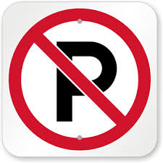
STUDENTS ONLINE

Students and their parents are encouraged to use Students Online (https://studentsonline.bos.nsw.edu.au/) as a resource to support their study and answer any questions they may have about the HSC.

Your student Number and PIN were provided to you in Year 10 when you completed “All My Own Work”.

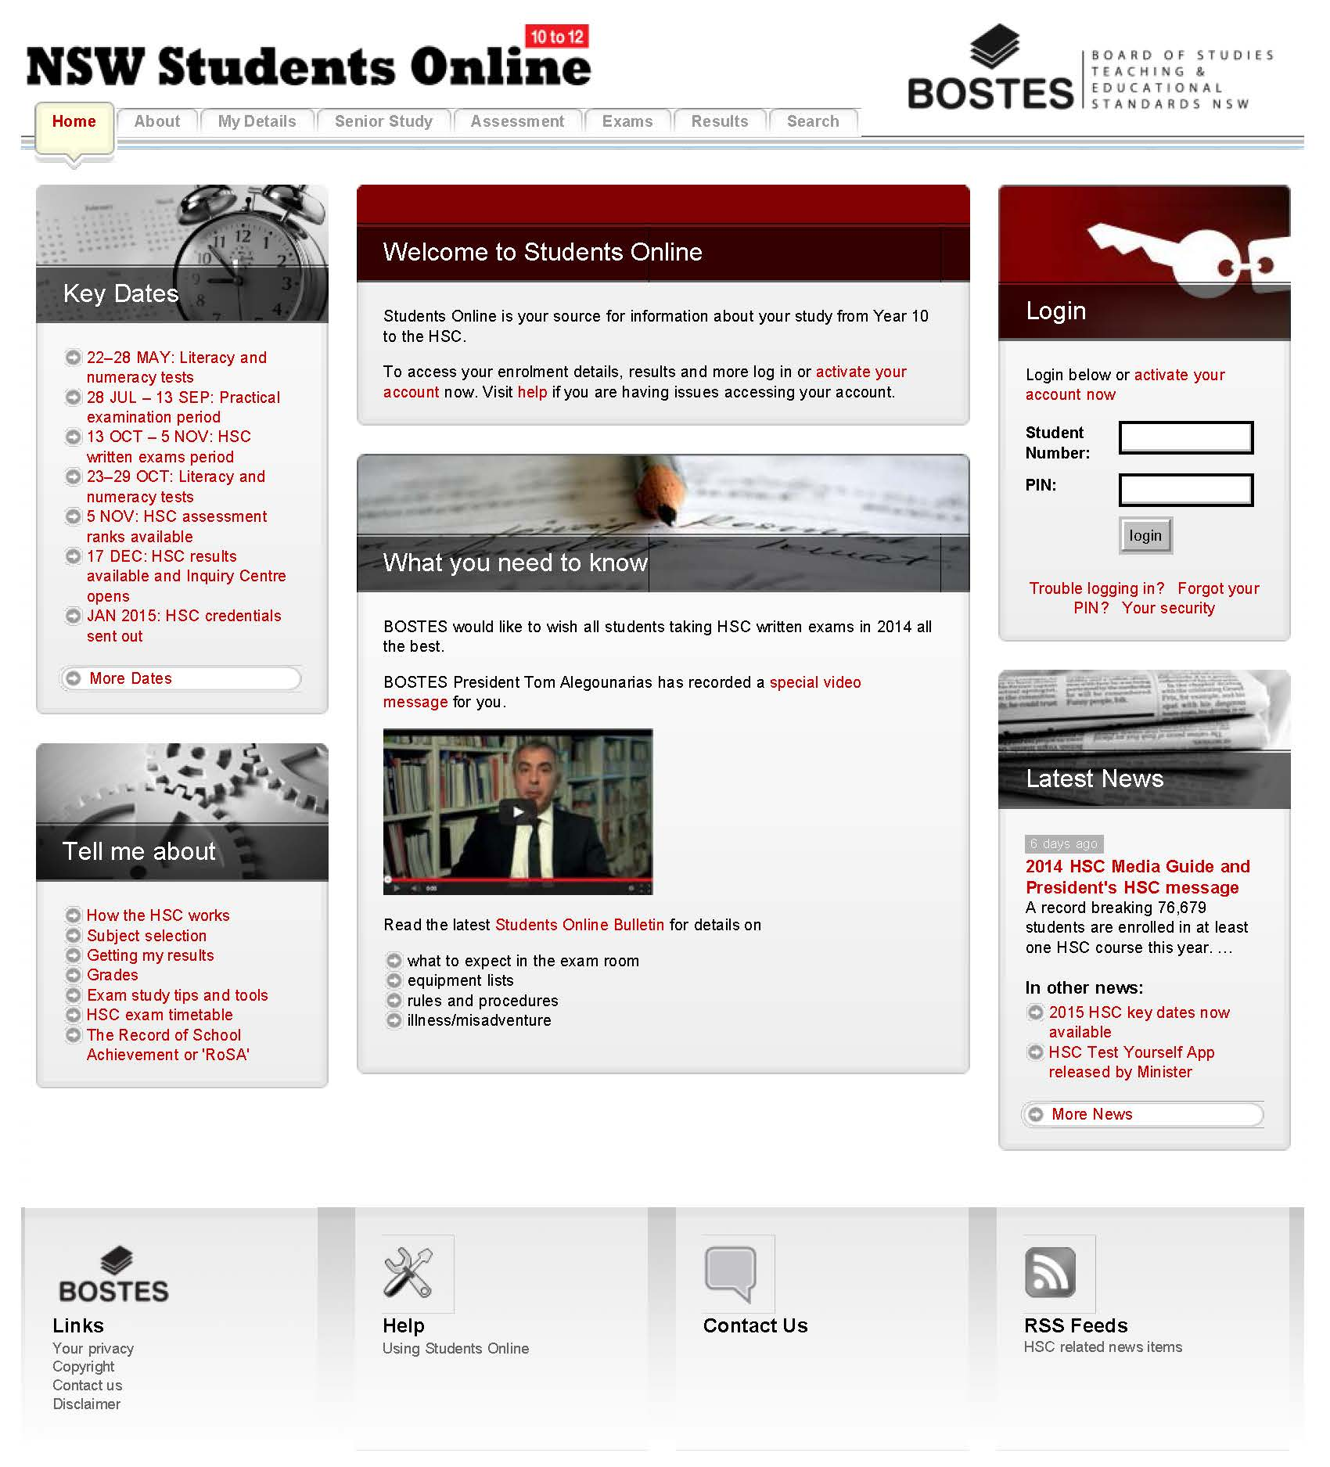

HSC REQUIREMENTS - HSC RULES AND REGULATIONS
Each Year 12 student is required by NESA to complete a 'Confirmation of Entry' form which includes the following declaration:
Student Declaration
I declare that :
- I understand the requirements for the award of the Higher School Certificate;
- I have checked my entry and certify that my personal details and course entry details are correct;
- I have completed all requirements for courses having a preliminary component ;
- I am aware of the restrictions on eligibility entry for certain language courses and English (ESL), and I am eligible for the courses in which I am entered;
- I have read and discussed with my parent/guardian/carer the Higher School Certificate Rules and Procedures, including those on plagiarism and malpractice, and have retained a copy of these rules,
- I will comply with the examination rules set out in the Higher School Certificate Rules and Procedures;
- I am aware of the conditions governing the award of examination marks in each course, and the award of the Higher School Certificate;
- I am prepared to attend examinations at such times and centres as may be arranged by NESA, at my own expense;
- I am aware that any major works or projects that form part of the examination in any course must be undertaken under the supervision of my class teacher and that, when submitting works I will be required to have the work certified as my own;
- I am aware that enrolment in a VET Frameworks course requires me to complete work placement and that failure to do so will result in the course not being reported on my Record of Achievement;
- I understand that the name on my Higher School Certificate will be exactly the same as the name appearing on this confirmation of entry;
- I am aware that my contact details may be supplied to organisations awarding prizes for exceptional achievement in the Higher School Certificate;
- I am aware that my marks will be forwarded to the Universities Admissions Centre (UAC),
- I have confirmed all of the above information is correct; and
- I understand that if this declaration contains false information I might not be eligible to receive my Higher School Certificate results.

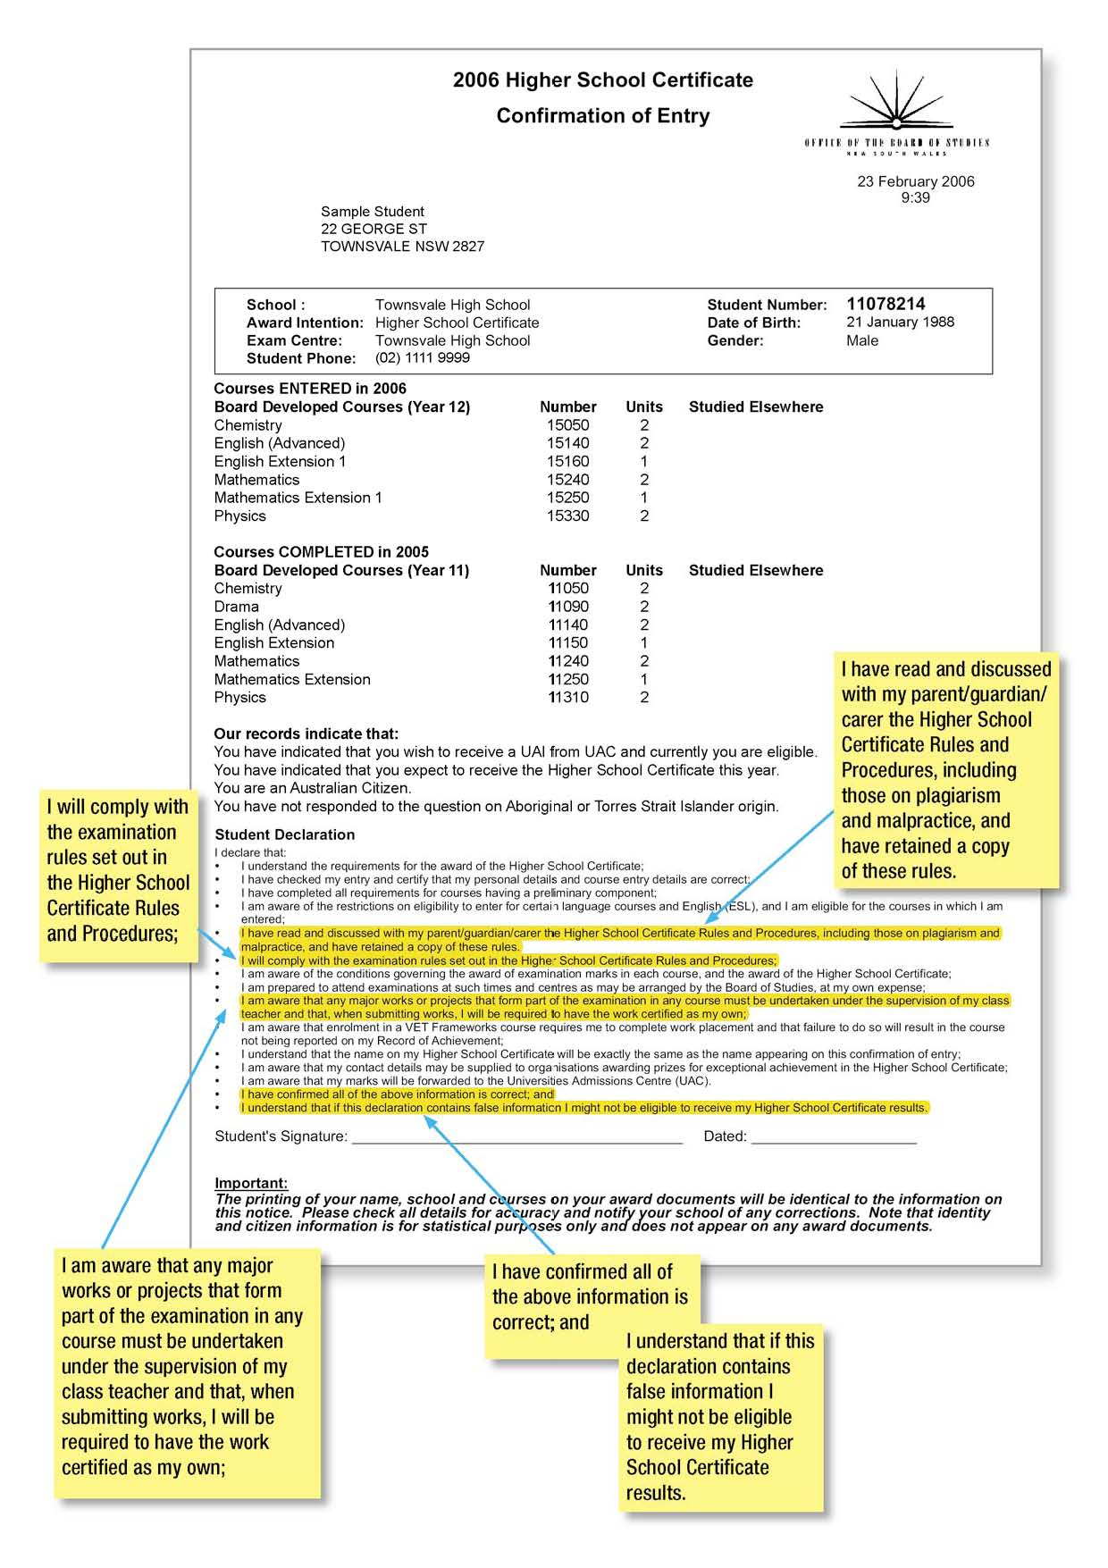
STUDENT PATTERN OF STUDY

To be eligible for the Higher School Certificate, each Year 12 student must satisfactorily study:
- a minimum of 10 units
- at least six units of Board Developed Courses including at least two units of a Board Developed Course in English
- at least three courses of two units value or greater
- a maximum of six units of courses in science
- at least four subjects.
To be eligible for an Australian Tertiary Admission Rank (ATAR) a student must satisfactorily complete:
- at least ten units of Board Developed Courses
- at least two units of English
- at least three courses of two units value or greater
- at least four subjects
Note: a maximum of 2 units of category B courses may be included in the ATAR calculation

DETERMINING A STUDENT'S ACHIEVEMENT IN THE HSC
A student's achievement in the HSC consists of their results in each of the courses they study.
Collectively these results show the relative strengths the student has demonstrated across their selection of courses.
Since 2001, a student's achievement for each course is usually reported by an examination mark, an assessment mark, an HSC mark (the average of the first two) and a performance band. These marks and bands relate to specific standards of achievement which were established in 2001. Every year the achievements of students in a course are reported against the same achievement standards, making it possible to compare the performances of students in a course across different years. Other interim marks and similar information are not reported as they are simply working information that assists in determining a student's result in relation to the standards for the course.
The following steps are involved in producing the HSC results for students for each course they study:
- Conducting assessment tasks to determine their raw school assessment marks
- Marking their examination responses to determine their raw examination marks
- Moderating their raw school assessment marks by using the raw examination marks
- Aligning their raw examination marks to the standards-based reporting scale
- Aligning their moderated assessment marks to the standards-based reporting scale
- Calculating the HSC mark.
The key aspects of these steps are summarised below.
1. CONDUCTING ASSESSMENT TASKS TO DETERMINE STUDENTS' RAW SCHOOL ASSESSMENT MARKS
For each course schools conduct an assessment program during Year 12 in accordance with NESA requirements. This involves developing and administering a number of assessment tasks, usually four. Each task contributes a certain amount to the total assessment mark. The tasks done towards the end of Year 12 are usually worth more than those done earlier in the course.
Schools plan the assessment program so that the tasks assess the outcomes of the course in accordance with weightings specified by NESA. Schools provide students with information about each task and the total assessment program. This includes the nature and requirements of each task, its weighting in the assessment program, when it will be sat and/or due and how it will be marked. After each task schools give students detailed feedback on how they performed and how they can improve.
At the end of the assessment program for a course schools combine the marks awarded for each task according to the stipulated weightings. The school then submits a single mark for each student in each course to NESA. NESA stores these marks until after the examinations are finalised.
Students are not told their submitted school assessment mark. This is because these marks need to be moderated so that the assessments from different schools are given a 'state-wide currency'. This is sometimes referred to as 'putting the assessments from every school on the same scale'. However, students are given a report that shows their position in their school group for each course they have studied based on their assessment mark. If a student feels that their position in any course does not agree with where they thought they would be placed they can ask the school to review their assessment. There are limits on the grounds for such reviews and for any subsequent appeal to NESA. For example, the marks awarded for any particular task are not part of this review process. Such matters must be raised at the time the tasks are handed back to the students.
2. MARKING EXAMINATION RESPONSES TO DETERMINE STUDENTS' RAW EXAMINATION MARKS
The marking of the examination papers for each course is managed by a Supervisor of Marking. The Supervisor of Marking selects Senior Markers (team leaders) and general markers. The markers are organised into teams, usually of six to eight, under the leadership of a Senior Marker. Each team usually marks only one examination question, or one section of the examination.
At the beginning of the marking operation only the Supervisor of Marking and Senior Markers, together with the Chief Examiner, attend the centre. The Chief Examiner is the person who chaired the committee that developed the examination paper. During these early sessions these people read many student responses, check them against the marking guidelines and collect specific student responses and other materials that will be used to train the markers. They check to see that the proposed marking guidelines will enable markers to reliably award marks to the full range of student responses and will obtain an appropriate level of discrimination. Although the students' examination marks will eventually be adjusted to align to the standards used to report student achievement, it is important to have a marking scheme that adequately discriminates between the quality of responses. At the end of this period the Chief Examiner reviews the marking guidelines and if necessary makes adjustments in consultation with the Supervisor of Marking.
When the markers first attend their marking centre their Senior Marker helps them become familiar with the question they are to mark and the marking guidelines they are to apply. This is done by having the markers read the student responses previously selected by the Senior Marker as being typical of responses at various points in the marking scheme. The marking team spends time discussing these typical responses.
The markers then commence a period of 'pilot' marking. This involves marking responses and recording the marks they believe each response should receive. The Senior Marker checks the marks awarded to some responses by each of his/her markers. Statistical reports that show the pattern of marks produced by each marker assist in this process. The Senior Marker then decides when his/her markers are ready to commence the actual marking.
Examination questions requiring students to supply a response fall into two categories: short response and extended-response. Short-response questions range from those requiring students to respond in a single word or number to those requiring perhaps a page or two of writing or the solution to a mathematical problem. For these questions it is possible to be quite explicit about the range of different responses or points that students can make that will be accepted as fully correct or worthy of some marks. Such responses are generally only marked by a single marker. The processes of check marking, statistical analyses and control scripts enable the senior marker to ensure that each marker is reliably and accurately applying the marking schemes.

In the case of extended response questions, students can produce a relatively wide range of valid responses to the question. Students might draw on a range of relevant knowledge and skills to produce a response that may be many pages in length. The marking scheme for such questions consists of the marking guidelines and a selection of student responses with annotations to clarify the guidelines.
The responses to such questions are independently and at times double-marked. That is, two markers each award a mark for the response, not knowing what mark has been awarded by the other. These two marks are compared. If the difference between the two marks is more than one third of the mark range for that question the response is marked a third time. Established 'discrepancy resolution' procedures are then applied to determine which two final marks will used. The Senior Marker usually conducts this 'discrepancy resolution' procedure. The student receives the average of these two marks for the question.
Markers record the marks for each student's response into the computer. Reports are produced to enable Senior Markers and clerical support officers to conduct the discrepancy resolution procedure and to identify any missing marks. Any sheets used to capture student responses to sections of the examination consisting of multiple-choice or other objective-response items are also sent for scanning.
A combination of different processes is used to monitor the reliability of the marking operation. These include having the Senior Markers following a program of 'check marking' a sample of scripts previously marked by each marker and checking whether they agree with the marks awarded; special statistical reports that show the pattern of marks awarded by each marker in each session; and the use of 'control scripts' which involves having every marker in a team mark a particular script, comparing the marks awarded by each marker and identifying any significant discrepancies between the marks awarded. These strategies enable the Senior Marker to identify any cases of a marker applying the marking scheme incorrectly or inconsistently.
Once the marking operation is complete the marks awarded to a student for each question in an examination are added up to produce the students' raw examination mark. For those examinations that consist of some compulsory questions and some optional questions an additional step is taken before the marks are added up. A process referred to as {optional question scaling' is applied. The final marks awarded to the students who have answered each optional question are statistically adjusted by taking into account the pattern of marks gained by that group of students on the compulsory questions. This ensures students are not unfairly advantaged or disadvantaged by choosing an easier or more difficult optional question.
3. MODERATING STUDENTS' RAW SCHOOL ASSESSMENT MARKS
As every student in the state studying a course sits for the same examination the examination marks have a state-wide currency. On the other hand, the school assessment marks only have a school-wide currency as each school is responsible for setting and marking the assessment tasks for their school alone. For this reason the assessment marks awarded by the schools must undergo a 'moderation' process so that they can be validly compared. Sometimes this is referred to as 'putting the assessments from each school onto a common scale'.

The moderation of assessment marks is a statistical procedure that adjusts the assessment marks a school has awarded to its students for a course by using the examination marks awarded to those students. For each course the procedure adjusts the mean of the school assessments to be equal to the mean of the examination marks obtained by the group. It also sets the top school assessment mark to be equal to the top examination mark, and sets the bottom assessment mark to be equal to (or close to) the bottom examination mark. All other assessment marks are adjusted accordingly. In performing this adjustment the general shape of the distribution of assessment marks submitted by a school is maintained. As a result all assessment marks are converted into the same 'currency' as the examination marks. These marks are not released as they still need to be put through a further adjustment.
4. ALIGNING STUDENTS' RAW EXAMINATION MARKS TO THE STANDARDS-BASED REPORTING SCALE
Since 2001 the achievements of students in an HSC course have been reported each year in relation to the same set of standards. This means that marks reported to students for a course in different years can be compared. It also means that it is possible to make judgements about the relative performances of cohorts of students over time.
As students sit for a different examination paper with different marking guidelines each year, a procedure is used to enable the raw examination marks awarded each year to be given meaning by aligning them to the standards and the reporting scale used by NESA.
Teams of specially trained teachers (referred to as 'judges') follow a rigorous, multi-stage procedure to identify what raw examination mark each year they believe corresponds to the borderline between each of the standards. The standards are referred to as 'performance bands'.
A critical part of the procedure is to have judges use the 'standards packages' published on the NESA website to develop a clear understanding of the knowledge, skills and understanding typically possessed by students who are at the borderlines between the performance bands for a course. The procedure then involves the judges first working independently, and then working collaboratively; to determine the marks they think students at each borderline would obtain for each question on that year's examination. During the procedure the judges look at special statistical reports and samples of student responses to check and refine their initial decisions. At the end of the procedure each judge's borderline cut-off marks for each question are added up to produce the judge's recommended borderline cut-off mark. The average of the cut-off marks from all members of the team becomes the team's recommended borderline cut-off mark.
Very specific information is provided to the judges to assist them in applying the procedure. Other information that would prejudice the procedure is withheld. This withheld information includes knowledge of the borderline cut-off marks from previous years and certain statistical data that would indicate the raw distribution of marks achieved by students in examination questions.
Once the judges have submitted their recommended cut-off marks the HSC Consultative Committee undertakes a thorough review of the work of each team and their application of the procedure. The committee then determines whether the procedure has been applied correctly and considers any other factors that may have affected the marking procedures. Finally, the committee then determines the final borderline cut-off marks that will be used.
The following simple mathematical technique is then used to align the raw examination marks to the reporting scale.
The mark that is the borderline between Band 5 and Band 6 is adjusted to 90, the mark that is the borderline between Band 4 and Band 5 is adjusted to 80, the mark that is the borderline between Band 3 and Band 4 is adjusted to 70, the mark that is the borderline between Band 2 and Band 3 is adjusted to 60, the mark that is the borderline between Band 1 and Band 2 is adjusted to 50. A mark of100 stays at 100 and a mark of 0 stays at O.
This means that 90 is the lowest mark to receive a Band 6. Students who receive a mark on or above the borderline between Band 5 and Band 6 will receive an examination mark somewhere between 90 and 100, using a technique referred to as interpolation. Similarly, students who obtain raw marks between the Band 2/Band 3 and the Band 3/Band 4 borderlines receive examination marks between 60 and 69.
By looking at the descriptions of the standard of achievement associated with each band (summarised on the reporting scale), students, teachers and the public can see the level of knowledge, skills and understanding typically achieved by students who have obtained each band. More detail on the things students who have obtained each band know and can do may be seen by looking at the student work samples (examination questions and responses) in the standards packages published on the Board of Studies website.
A student who has received one of the higher marks in the band has a relatively stronger grasp of the knowledge and skills required to be in that band. A student with a mark towards the bottom of the band typically has the knowledge and skills required of that band, but to a lesser degree.
5. ALIGNING STUDENTS' MODERATED ASSESSMENT MARKS TO THE STANDARDS-BASED REPORTING SCALE
After the raw examination marks are aligned to the reporting scale in the manner described above, exactly the same adjustments are made to the moderated school-based assessment marks. That is, the borderlines between the bands determined through the standards-setting procedure become the borderlines for the moderated raw assessment marks. It is appropriate to apply the borderlines from the examination to the moderated school assessment marks because both sets of marks are in the same currency.
In this way the assessment marks reported to students for each course are related to the same set of standards established for the examination marks in that course.
6. CALCULATING THE HSC MARK
The HSC mark a student receives for each course, which is reported alongside the examination mark and the assessment mark, is simply the average of the examination mark and the assessment mark. Decimal places are not reported; half-marks are rounded up to the nearest whole number.
The HSC mark determines the performance band that a student is awarded for each course.
The school cannot provide you with an estimated HSC mark OR ATAR.

CHANGES TO YOUR PATTERN OF STUDY
Students who are studying more than 10 units in Year 12 may discontinue a course at any time, provided that they still satisfy the requirements above. Students who wish to discontinue a course must provide a note, listing the reasons for the requested change and signed by the student and a parent or guardian. The note is then to be handed to the Head Teacher Secondary Studies who will check your eligibility for the HSC and ATAR and then arrange for the amendment of your HSC entry with the Board of Studies.
Students who are having difficulty coping with meeting the demands of their pattern of study may wish to consider options such as accumulation or Life Skills courses. Students considering these options should discuss their options with one of our counsellors, the Year 12 Year Advisers, the Year 12 Deputy or Principal.

HSC EXAMINATIONS: PROJECTS, SUBMITTED WORKS AND PERFORMANCES INFORMATION FOR STUDENTS
If you have chosen to study a course that has a practical project, submitted work or performance as part of the HSC examination, it is important that your project is all your own work (apart from any approved assistance), and that you and your school are able to certify to NESA that this is the case.
What does certification of my project/performance mean?
You will be required to sign a declaration similar to the following:
I declare that:
- the planning, development, content and presentation of this project is my own work, except for the limited material, if any, drawn from acknowledged sources
- I have not copied another person's work
- I have not submitted this work, in any part, for any HSC examination or assessment task in any other course
- I have not worked on it after 9 am on the completion/hand-in date
- I have read and discussed with my parent/guardian/carer the Higher School Certificate Rules and Procedures, including those on plagiarism and malpractice
- I understand that if this declaration contains false information I might not be eligible to receive my Higher School Certificate results.
Your teacher will ask you to sign the declaration when you hand in your project or submitted work, or when you present for your performance examination.
Your teacher and your principal are also required to sign a declaration. They must certify that your project, submitted work or performance:
- complies with NESA’s requirements
- is your own work
- has been done under their supervision and is consistent with other examples of your work.
If you are planning a project that will need you to work away from school, your teacher will need to agree that they can supervise you and be sure that the work is all your own. You must obtain your school's permission before you start on such a project.
HOW WILL MY TEACHER KNOW THAT MY PROJECT IS ALL MY OWN WORK?
Your teacher is required to supervise your work and monitor its progress. You should keep a written record of meetings and discussions with your teacher about your work. In most courses with a project you will be required to keep a journal, diary or log. You will need to show it to your teacher regularly so that your teacher is aware your work's progress. If your work is on computer you should save copies of the work at various stages of development. Date-stamped digital photos are also useful records of progress of your project.
AM I ALLOWED TO RECEIVE OUTSIDE ASSISTANCE WITH MY PROJECT?
Your teacher will discuss your project with you and provide feedback on its development. This is not regarded as 'outside assistance'. If your teacher needs to work on your project -for example, it may require equipment that students are not permitted to use at school-this is regarded as 'outside assistance' and must be acknowledged in your project journal or folio.
If you need to ask someone else to work on your project (for example, a plastics expert to mould a piece of plastic for your project), you must discuss this with your teacher before any work is undertaken. Your teacher will advise you if such work is permitted and, if so, how you should acknowledge this assistance in your folio, journal or other documentation.
Some students may wish to have an outside 'mentor' for specific advice or assistance with aspects of their project. It is very important that you discuss this with your teacher to make sure that the assistance you are planning to get is allowable, and that it is appropriately acknowledged. If you wish to have someone other than your teacher (for example, your parents or a tutor) review your work and comment on it for you, you should discuss this with your teacher beforehand, to clarify how much assistance and advice is appropriate, and whether it should be acknowledged.
Remember: if no assistance is acknowledged by you, then your signature on the declaration form certifies that the work you submit is entirely your own original work. This means that the words, ideas, designs and/or workmanship are all your original work, and that you have received no outside assistance whatsoever.
HOW CAN I ENSURE THAT MY WORK WILL BE CERTIFIED?
• If you are planning to work on your project away from school, you must obtain your teacher's permission first. You will need to discuss whether your teacher can supervise it, and how they will supervise it and be sure that the work is all your own.
• Ensure that your teacher sees your work in progress, and is aware of your intentions for your project.
• Make sure you have evidence of the development of your project that shows your project is all your own work and is consistent with other work you have produced.
• If any person other than you works on or contributes to your project, make sure this is acknowledged in your journal/logbook/folio or other appropriate written record.
• Complete all work by the due date set by your teacher.
Hand in all documentation as advised by your teacher and required for the marking of your work (this might include logs, process diaries, composition portfolios etc).
NESA also state that projects must not contain materials or processes that are dangerous to the health and safety of anyone involved. Prohibited weapons, replicas or related articles must not be used, produced or displayed. There are specific course requirements including size, weight and duration limits for projects and performances. Penalties for not complying with requirements could include loss of marks.
Students should note that projects will not be eligible for public exhibitions and performances if they do not meet NESA’s requirements.
WHAT WILL HAPPEN IF MY TEACHER IS NOT ABLE TO CERTIFY MY PROJECT?
If a project is not certified there may be a reduction of marks or a mark of zero for the project. Your teacher will complete a report giving the reasons why your project cannot be certified. You will have the opportunity to respond to your teacher's report. If the reason for non-certification is suspected cheating or work that is not your own, you will need to provide evidence that your project is all your own work, and that any outside assistance has been acknowledged.
NESA will make a judgement as to whether any penalty will be imposed, and you and your school will be notified at the time of the release of the HSC results.
For more information, refer to the pamphlet HSC ASSESSMENTS AND SUBMITTED WORKS: ADVICE TO STUDENTS, which is available on the NESA website.

MALPRATICE
All work presented in assessment tasks and HSC examinations (including submitted works and practical examinations) must be your own or must be acknowledged appropriately. Malpractice, including plagiarism, could lead to you receiving zero marks for the task or examination, and will jeopardise your HSC results.
Malpractice is any activity that allows you to gain an unfair advantage over other students. It includes, but is not limited to:
- copying someone else's work in part or in whole, and presenting it as your own
- using material directly from books, journals, CDs or the internet without reference to the source
- building on the ideas of another person without reference to the source
- buying, stealing or borrowing another person's work and presenting it as your own
- submitting work that another person, such as a parent, coach or subject expert, has contributed to substantially
- using words, ideas, designs or the work of others in practical and performance tasks without appropriate acknowledgement
- paying someone to write or prepare material
- breaching school examination rules
- cheating in an HSC examination
- using non-approved aids during an assessment task
- contriving false explanations to explain work not handed in by the due date
- assisting another student to engage in malpractice.

In the case of suspected plagiarism, students will be required to provide evidence that all unacknowledged work is entirely their own. Such evidence might include, but is not limited to, the student:
- providing evidence of and explaining the process of their work, which might include diaries, journals or notes, working plans or sketches, and progressive drafts to show the development of their ideas
- answering questions regarding the assessment task, examination or submitted work under investigation, to demonstrate their knowledge, understanding and skills.

Dishonest behaviour carried out for the purpose of gaining unfair advantage in the assessment process constitutes malpractice, or cheating. Malpractice in any form, including plagiarism, is unacceptable. NESA treats allegations of malpractice very seriously and detected malpractice will limit a student's marks and jeopardise their HSC. Should malpractice be suspected, students will be required to demonstrate that all unacknowledged work is entirely their own. Serious and deliberate acts of malpractice amount to corrupt conduct and, where appropriate, NESA will report matters to the Independent Commission Against Corruption.

All schools are required to inform NESA of incidences of malpractice in assessment tasks.

DISABILITY EXAMINATION PROVISIONS
Disability exam provisions in the HSC are practical arrangements designed to help students who couldn't otherwise make a fair attempt to show in an exam room what they know.
The provisions granted are solely determined by how the student's exam performance is affected. Provisions may include braille papers, large print papers, use of a reader and or writer, extra time or rest breaks.
APPLYING FOR DISABILITY EXAMINATION PROVISIONS
Disability Examination Provisions information guides are available to schools from Schools Online for students who intend to sit for the Higher School Certificate examinations.
Students who wish to apply for disability examination provisions should see the Year Adviser or School Counsellor. The Year Adviser and School Counsellor will need to inform the classroom teachers.
The student will need to see the Head Teacher Secondary Studies for an official NESA application form. This form will need to be completed by a specialist, or school counsellor. The doctor MUST:
- Indicate the provisions for which the student is applying. In doing this, it is important to refer to the application form, which gives examples of the provisions that NESA considers most appropriate for a particular special examination need.
- Indicate how the disability affects the student's work in the classroom and in examination situations.
- Supply evidence to support the disability provision for which you are applying for. A guide to the various types of evidence required is provided in the application form.
It is important that the school return the completed application form to NESA by the due date. The due date is always the last day of Term 1, except for applications based on chronic fatigue syndrome, post-viral syndrome, Ross River fever or glandular fever, which should be submitted in July of the examination year, with teacher comments and medical documentation also dated July. If all the necessary information is not provided, some requested provisions may be declined due to insufficient evidence.
HOW DOES THE PROCESS WORK?
Once NESA has received the application, a letter acknowledging receipt is sent to the school. The application is processed at NESA.
NESA has a Disability Provisions Panel; these specialists include medical practitioners, educational psychologists and consultants for the visually or hearing impaired. The basis of the application and evidence presented will determine which specialist will review the file.
When a final decision has been made, written notification of the approved and/or declined provisions is sent to the principal, and to the student through the Head Teacher Secondary Studies.
APPEAL PROCEDURES
Should a student wish to appeal NESA’s decision to decline a provision, the appeal must be submitted through the school within 14 days of receiving the special examination provisions decision letter. The appeal must state the reason why the decision is considered unacceptable, making reference to the evidence supplied in the original application.
The appeal must include new supportive evidence, such as a further medical report, which clearly states why the student needs the provision, or additional reading, writing or spelling test results. NESA will conduct an independent review and a decision will be made within twenty-one (21) days. The outcome of the appeal will be advised to the school and to the student.
Students may apply for disability provisions for the following reasons:
- Significant heath impairment
- Significant physical disability
- Learning disability
- Severe language disorder
- Hearing impairment
- Vision impairment
- Illness (physical or psychological)
In order to be awarded disability provision for these reasons it is necessary for students to meet set criteria including specific tests and statements from independent professionals.
The types of disability provisions available are:
- Rest breaks
- Permission to stand, stretch or move around the room
- Permission to leave the room (under supervision)
- Medication (food and drink)
- Extra reading time (in production time)
- Extra writing time
- Reader
- Scribe
- Computer
- Separate room
- Alternative formats

RESEARCH LEAVE
Year 12 students may apply for approved leave to undertake research, investigations or inquiries on an individual basis. For example, this form of leave is available for individual students who may be undertaking research for the preparation of PIPs or HIPs.
Applications for Research Leave must be wholly completed and submitted at least one week prior to the proposed day of leave. An application for Research Leave must be obtained from the Head Teacher Secondary Study.
The student must include a full explanation of the need for the leave. The form also requires the signatures of all of the student's teachers on the proposed day of Research Leave as well as the student's parents.
Research Leave will not be approved for days on which whole school activities are occurring such as swimming carnivals and athletics carnivals or when assessment tasks are scheduled.
Upon completion, the form is returned to the Head Teacher Secondary Studies who will issue the student with a Research Leave pass and make the appropriate notification (B) on the roll. The Head Teacher Secondary Studies will also ensure that the appropriate notice is placed on the daily absentee list on the day of the study leave.

COMPUTER WORK AND ASSESSMENT TASKS
Computer malfunction does not give sufficient ground for Misadventure appeals within the HSC Assessment tasks.
If a computer is used, the student is responsible for ensuring that:
- There is an alternative system available in case of computer or printer malfunction.
- Hard copies of work in progress are produced regularly.
- Each time changes are made the work is saved onto a back-up file. The back-up file should not be stored with the computer.

REQUEST FOR A SCHOOL CHARACTER REFERENCE
A) School Character Reference
As a service to students, the school is willing to supply character references for each Year 12 student who indicates that she would like one. The provision of student character references is not a requirement of the Department of Education and Training and is completed on a voluntary basis by Year 12 teachers at Cheltenham Girls' High School. Writing these references is an often time consuming task, coming at a time when teachers are facing all of the additional pressures of the end of school year.
It is for this reason that we ask that deadlines for handing in requests are maintained, as it is not possible to produce a character reference at a later time.
References summarise the student's commitment to the values of the school and records the contributions to school life that the student has made during her time with us. Additionally, the character reference summarises the student's personal learning habits on the basis of the assessments made by teachers and recorded on each semester's report. Whilst the character reference does list the extracurricular activities with which a student may have been involved, it does not record academic achievements per se. A student's academic achievement can be shown to a potential employer through the school academic reports.
B) Processing of Reference Requests
Students are first of all asked if they require a reference. For those students who continue to university, a reference may be irrelevant and by the time university studies are completed or they enter the work force it may well be out of date.
Students who do require a reference will need to complete a Reference Request Form that will provide relevant information to the Year Adviser in order to complete the reference. Deadlines for request forms are absolute as references take a considerable time to prepare. All students are required to sign the request form even if they indicate that they do not wish to have a reference.
References will refer to the school report for academic information as this avoids doubling up on information and students can take copy their reports for prospective interviewers if needed.
The reference will only list major awards for academic, service and sporting achievements. Extra curricula information will be the same as that indicated on the school report.
C) Academic Awards/ TAFE Awards
There are several categories of awards given to Year 12 students each year at annual Presentation Day. These awards are published as soon as practical after all assessments are completed. They are regularly updated as more awards become known.
TAFE awards are included in these lists as a courtesy. TAFE classes are not related to the school awards and TAFE should notify their own students however they send the awards to the school to be delivered to students.
Year 12 students are given a letter containing the details of Presentation Day and the rehearsal times for Year 12 students. Students must indicate whether or not they will be attending Presentation Day.
Students must take responsibility to check the boards of published results before they leave school and regularly during the exam period.
It is NOT possible to notify every student individually.

FINAL WEEKS OF SCHOOL FOR YEAR 12 STUDENTS
Year 12 final assembly is held in the school hall on Wednesday morning of the last week of Term 3. Parents and sisters are welcome to attend. All Year 12 students are required to attend the rehearsal the day before and the final assembly. Full summer uniform must be worn at the morning assembly. The Graduation Dinner follow that night at the Hornsby RSL club at 6.30pm. Full winter uniform must be worn at this event. Only parents or guardians are invited to attend the dinner to celebrate this milestone with their daughter.
"Muck Up" events are not permitted during the final weeks of school for Year 12. Year 12 students will not interfere with or disrupt the learning of other students in the school during this period of time. Vandalism or damage to school or the personal property of others will be referred to the police and additional school penalties may apply. Student leaders may bring requests regarding activities for the last week of school, on behalf of the year group to the Year Advisor and Mrs Bridge. Mrs Bridge will determine the approval of any event. Any unapproved activities may result in cancellation of the final assembly and dinner event for Year 12.

PRESENTATION DAY
The Presentation Day awards lists are published in approximately Week 8 of Term 3. This provides most students with sufficient notice that they will be required to attend Presentation Day to receive their award. In some cases some awards may not be determined before Year 12 students leave the school in the last week of Term 3. Examples of these awards are those for Major Practical Projects or Performances.
All Year 12 students will be expected to check the awards notices on the board outside the welfare office during the exam period. Teachers may also still use the DET email to contact students over the exam period. Please make sure you check your DET email regularly.
All students but especially those in leadership positions are advised to organise their "Schoolies Week" around this date so that they are available for the presentation day duties that form part of their leadership role. Student leaders should consult with Mrs Edwards if they are unsure about their role at Presentation Day Celebrations.

This handbook is issued
to all
Year 12 Students.
You should read it carefully and keep it handy.
It contains the expectations and many of the rules that you will be required to observe.
Failure to do so may have consequences that, in several instances, could impact on your HSC results.

